|  |  |  |  |  |  |  |  |  |  |  |  |  |  |
| --- | --- | --- | --- | --- | --- | --- | --- | --- | --- | --- | --- | --- | --- |
| https://encrypted-tbn3.gstatic.com/images?q=tbn:ANd9GcRR3rvvj_jpoN9msvSwXoccpHI_gZkuQ5HCtM28gQibp6sbgkEp**Vocales** | | | | **manzana** | **ma** | http://www.dibujoswiki.com/Uploads/dibujoswiki.com/ImagenesGrandes/sol-sonriente-8.jpg  **sol** | **sa** | http://us.123rf.com/400wm/400/400/iimages/iimages1209/iimages120900238/15249978-ilustracion-de-un-tambor-de-colores-sobre-un-fondo-blanco.jpg  **tambor** | | **ta** | http://www.eljardinonline.com.ar/imagenes/libroabierto.gif  **libro** | | **la** |
| **me** | **se** | **te** | **le** |
| **mi** | **si** | **ti** | **li** |
| **mo** | **so** | **to** | **lo** |
| **mu** | **su** | **tu** | **lu** |
| http://thumbs.dreamstime.com/z/rana-2624191.jpg    **R**  **r**    **Rana** | **ra** | **P**  **p**  **panda** | **pa** | http://1.bp.blogspot.com/-GthcaYDR8aY/TV79VjwATfI/AAAAAAAAB0g/53-NeskNtnw/s1600/bitter+naranja1.jpg  **naranja** | **na** | **C:\Users\Compaq\AppData\Local\Microsoft\Windows\Temporary Internet Files\Low\Content.IE5\GPUHX1X1\MC900391412[1].WMF**  **casa** | **ca** | [http://t2.gstatic.com/images?q=tbn:ANd9GcT-pw748HBGpRMfRn0k0sVtqADKe-Ixf4Ke6SFnFWJuvtGJwKfr](http://www.google.com.mx/url?sa=i&rct=j&q=dado&source=images&cd=&cad=rja&docid=SezynSYeDoSS6M&tbnid=Q-wlXYNKNx3T5M:&ved=0CAUQjRw&url=http://galeria.colorir.com/jogos/dado-pintado-por-iane-larissa-478574.html&ei=dwgkUra-IcXQ2QW9p4DABA&bvm=bv.51495398,d.b2I&psig=AFQjCNEoOG5lFQgbkqcivdBMTkCpv1osmg&ust=1378179538843712)  **D**  **d**  **dado** | | **da** | http://4.bp.blogspot.com/-Uh2vX_GHEdI/T2fcFeJHe5I/AAAAAAABGwM/H1PQ6eb-kUE/s1600/VACA+CONIE.gif  **vaca** | | **va** |
| **re** | **pe** | **ne** |  | **de** | **ve** |
| **ri** | **pi** | **ni** |  | **di** | **vi** |
| **ro** | **po** | **no** | **co** | **do** | **vo** |
| **ru** | **pu** | **nu** | **cu** | **du** | **vu** |
| **foca** | **fa** | [http://www.pt.clipproject.info/images/joomgallery/details/frias_imagens_35/barco_desenho_imagem_descarregar_20110831_2068898832.gif](http://www.google.com.mx/url?sa=i&source=images&cd=&cad=rja&docid=Y0JRB0P2BeR1VM&tbnid=W-qiEk4h_rlIYM:&ved=0CAgQjRwwAA&url=http://www.imagui.com/a/barco-animado-c4eax9Rgg&ei=Hw0kUqPDGsOvsQSgxoG4Bw&psig=AFQjCNExVWDruZwUtgy6CnTtOr547wLcZw&ust=1378180767488763)  **barco** | **ba** | **C:\Users\Compaq\AppData\Local\Microsoft\Windows\Temporary Internet Files\Low\Content.IE5\24WCCJ3U\MC900428363[1].WMF**  **jaula** | **ja** | http://relatorpopular.files.wordpress.com/2013/01/ncc83oncc83o.jpg?w=584  **Ñ**  **ñ**  **Ñiño** | **ña** | C:\Users\Compaq\AppData\Local\Microsoft\Windows\Temporary Internet Files\Low\Content.IE5\PYP73ZGC\MC900438167[1].WMF  **gato** | | **ga** | http://www.consumidor.gob.mx/wordpress/wp-content/uploads/2012/05/Hgastos_hormiga.jpg  **H**  **h**  **hormiga** | | **ha** |
| **fe** | **be** | **je** | **ñe** |  | **he** |
| **fi** | **bi** | **ji** | **ñi** |  | **hi** |
| **fo** | **bo** | **jo** | **ño** | **go** | **ho** |
| **fu** | **bu** | **ju** | **ñu** | **gu** | **hu** |
| **chupete** | **cha** | **llave** | **lla** | https://encrypted-tbn0.gstatic.com/images?q=tbn:ANd9GcRWPKDXkjqrfEvpD4_AzLumrlKTB2gsGNWSgFcKn13p5aXJ4JZoBw  **queso** |  | **C:\Users\Compaq\AppData\Local\Microsoft\Windows\Temporary Internet Files\Low\Content.IE5\KIS2KVWB\MC900437078[1].PNG**    **yoyo** | **ya** | https://encrypted-tbn2.gstatic.com/images?q=tbn:ANd9GcTHBhrRAPJ_zDD3f_r94G-lPMUhy_RMS_s8ng8sYoun09iO4Zry      **guitarra** | |  | **pingüino** | |  |
| **che** | **lle** | **que** | **ye** | **gue** | **güe** |
| **chi** | **lli** | **qui** | **yi** | **gui** | **güi** |
| **cho** | **llo** |  | **yo** |  |  |
| **chu** | **llu** |  | **yu** |  |  |
| http://t2.gstatic.com/images?q=tbn:ANd9GcTNRVzyyLSzMFEg__y2c3osB038R1wUL0ZIGvmYXOfnLZGAbxYCkg  **https://encrypted-tbn1.gstatic.com/images?q=tbn:ANd9GcQjkLNck6wW-QzsGFqPeBiRPw22vHOcueoDXXsol21HY_o7pE-ceQhttps://encrypted-tbn1.gstatic.com/images?q=tbn:ANd9GcQjkLNck6wW-QzsGFqPeBiRPw22vHOcueoDXXsol21HY_o7pE-ceQhttps://encrypted-tbn1.gstatic.com/images?q=tbn:ANd9GcQjkLNck6wW-QzsGFqPeBiRPw22vHOcueoDXXsol21HY_o7pE-ceQgenio** |  | C:\Users\Compaq\AppData\Local\Microsoft\Windows\Temporary Internet Files\Low\Content.IE5\GPUHX1X1\MC900290382[1].WMF  **cerilla** |  | **koala** | **ka** | http://files.amorsales.com/system_preview_detail_200003122-a9484a9e6f/Zapatos%20por%20Mayoreo%20Bonafini%20K-4%20zapatos%20de%20vestir%20para%20nino%20mayoreo.jpg  **zapato** | **za** | **xilófono** | **xa** | | http://2.bp.blogspot.com/-PxFd9WAIEwk/TdN282oihnI/AAAAAAAADHw/76l3uZ_kKh8/s1600/waterpolo.gif  **waterpolo** | **wa** | |
| **ge** | **ce** | **ke** | **ze** | **xe** | | **we** | |
| **gi** | **ci** | **ki** | **zi** | **xi** | | **wi** | |
|  |  | **ko** | **zo** | **xo** | | **wo** | |
|  |  | **ku** | **zu** | **xu** | | **wu** | |

**EL ABECEDARIO APRENDEMOS LAS LETRAS Y LAS SÍLABAS**

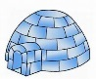

**S**

**s**

**M**

**m**

**T**

**t**

**L**

**l**

I i

**C:\Users\Compaq\AppData\Local\Microsoft\Windows\Temporary Internet Files\Low\Content.IE5\EWEG2Y5G\MC900300097[1].WMF**

E e

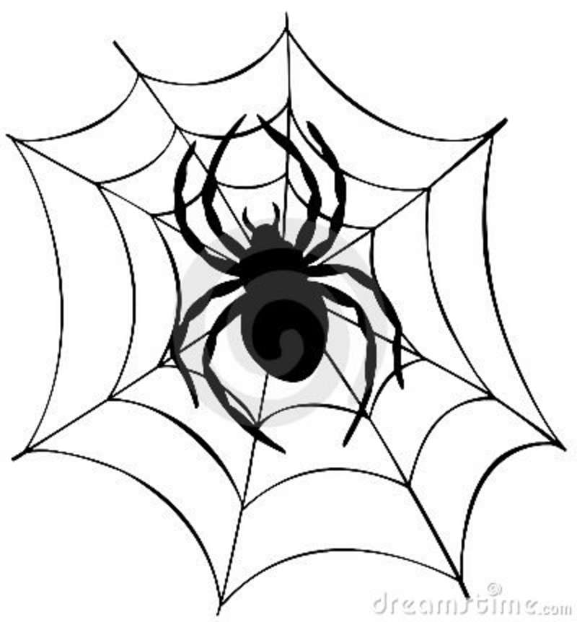http://us.cdn2.123rf.com/168nwm/freud/freud0806/freud080600119/3205172-ilustracion-de-uvas-con-hojas.jpg



O o

U u

A a a>

**C**

**c**

**N**

**n**

**V**

**v**

**B**

**b**

**J**

**j**

**G**

**g**

**F**

**f**

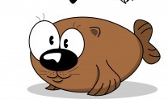

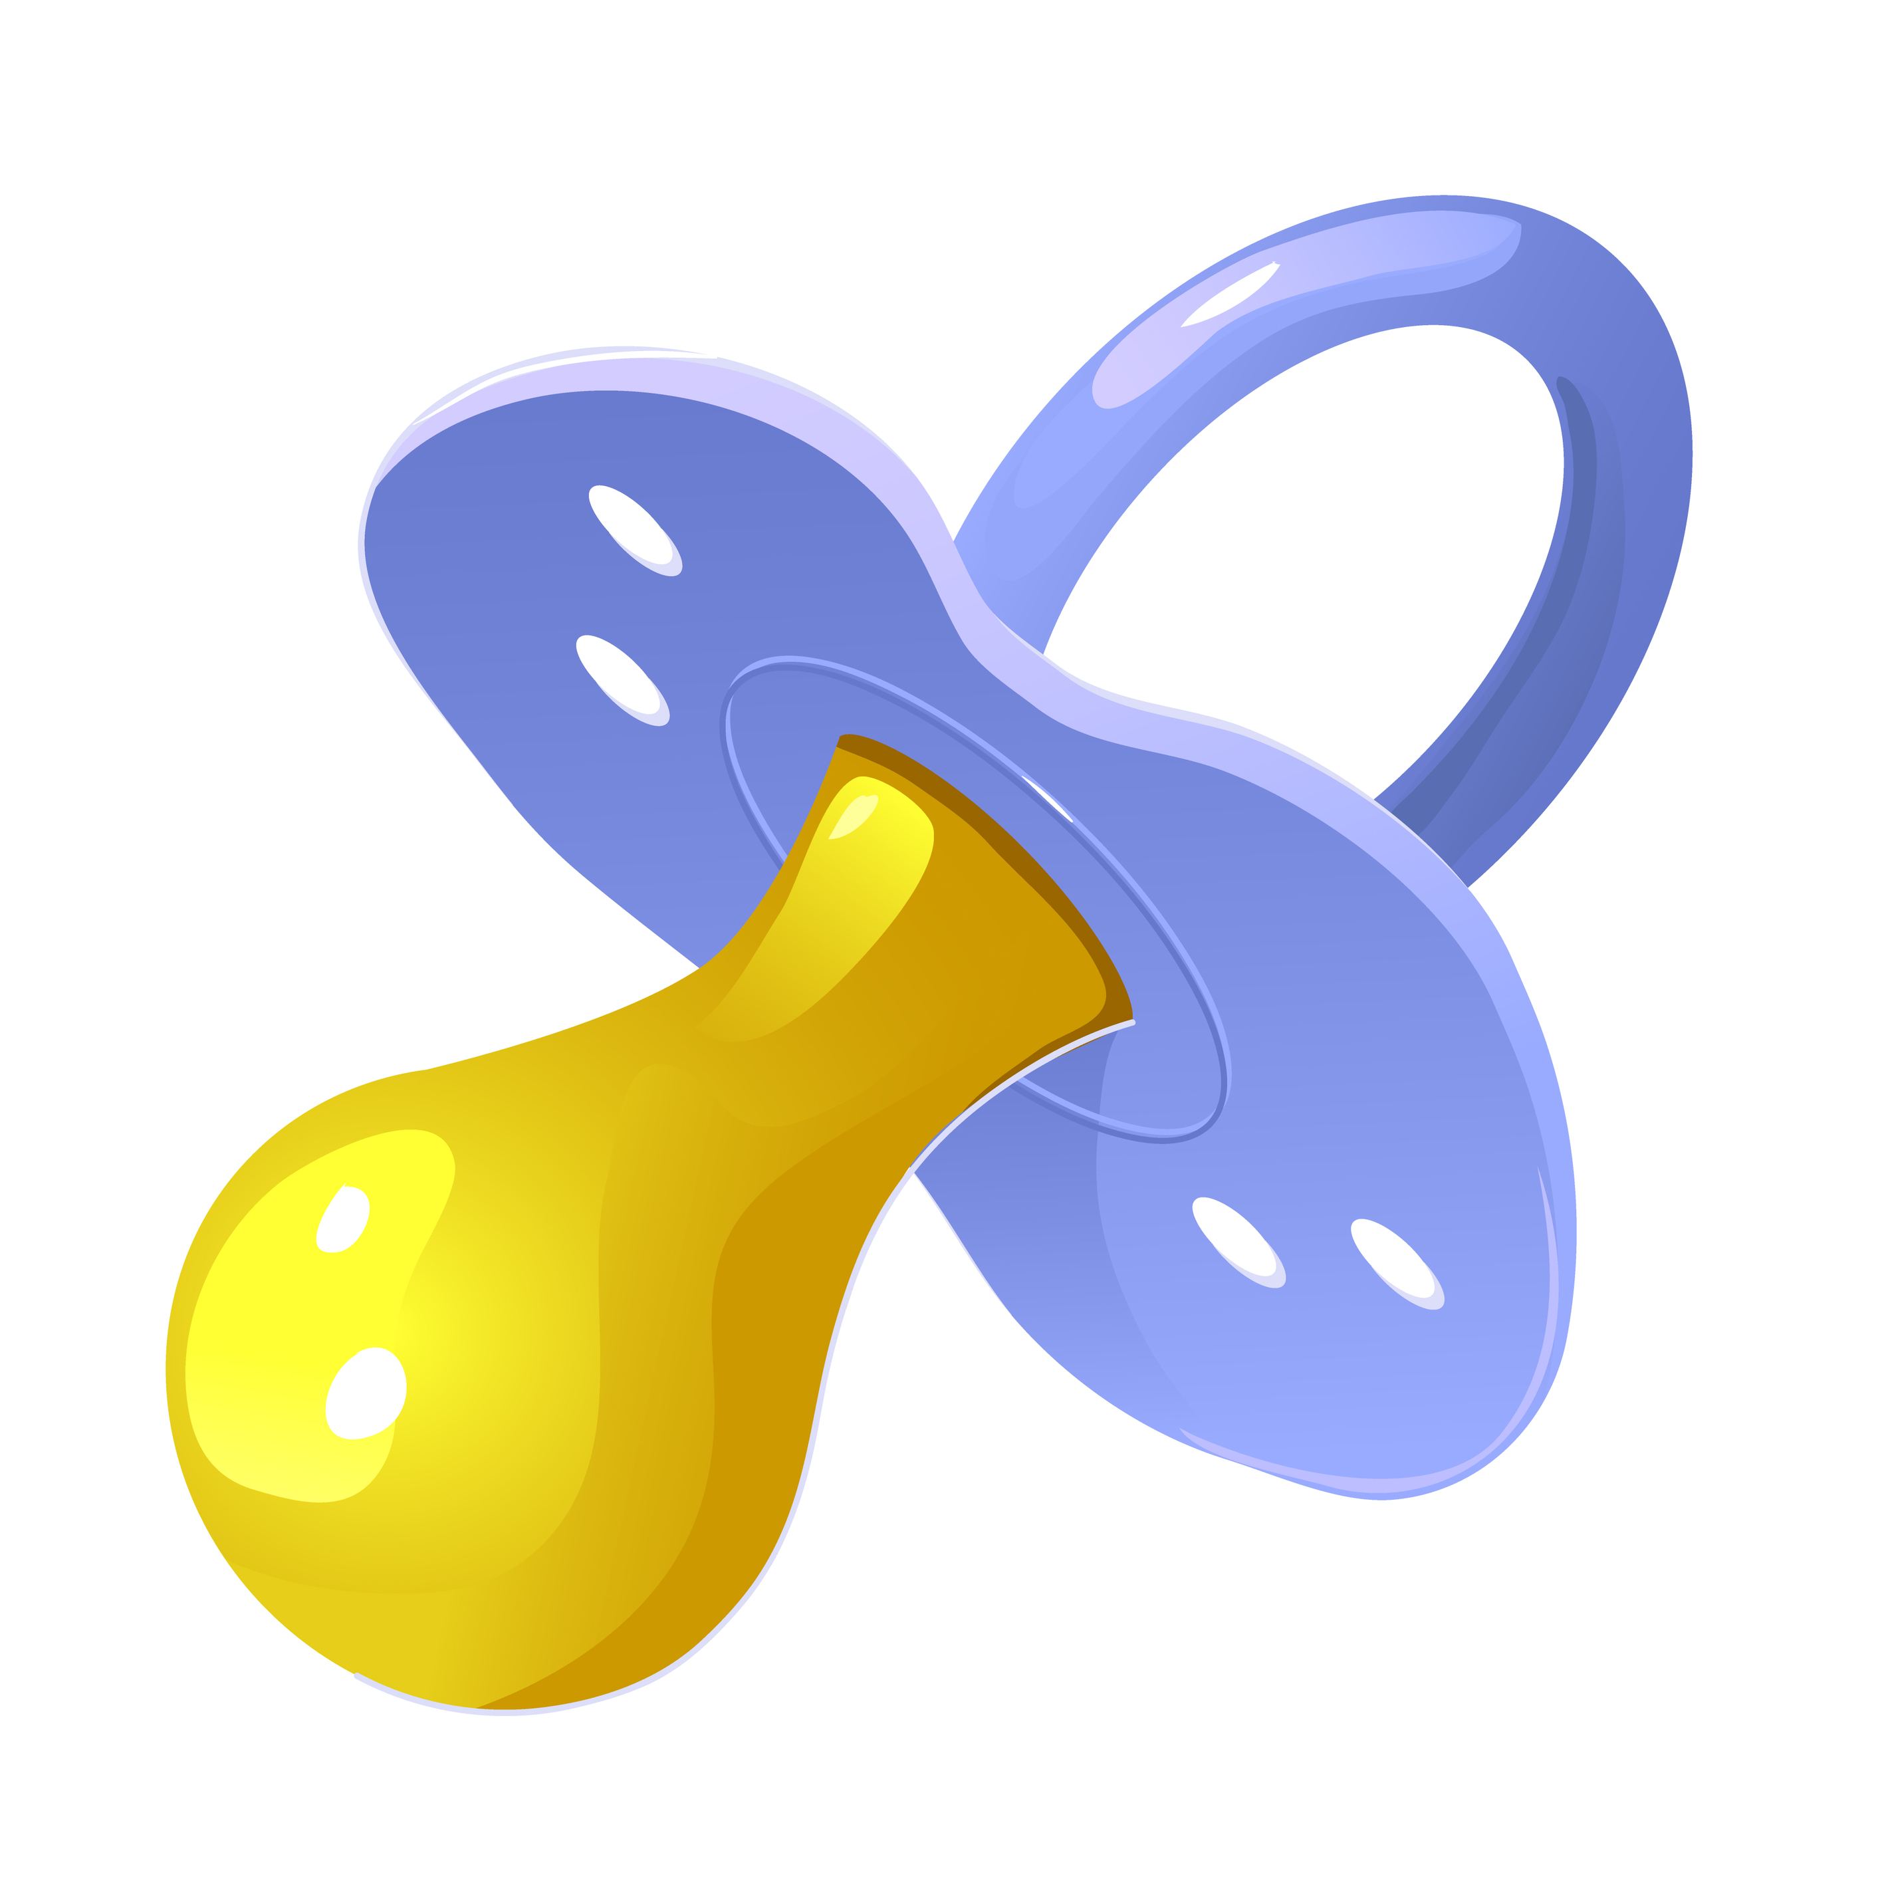

**G**

**g**

**G**

**g**

**Ch**

**ch**

**Y**

**y**

**Q**

**q**

**Ll**

**ll**

**W**

**w**

**K**

**k**

**Z**

**z**

**X**

**x**

**C**

**c**

**G**

**g**

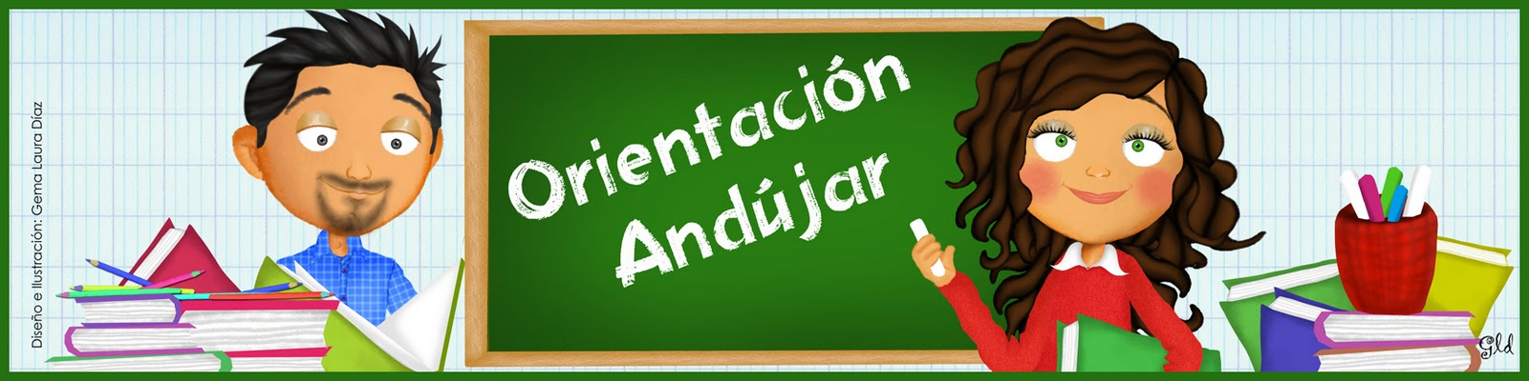

[**www.imageneseducativas.com**](http://www.imageneseducativas.com)[**www.orientacionandujar.es**](http://www.orientacionandujar.es)